PROGRAM 2

import java.util.Scanner;

public class sav

public static void main(String[] args) {

Scanner sc = new Scanner(System.in);

int n = sc.nextInt();

if (n<=0) {

System.out.println("Invalid number of days");

return;

}

int[] p = new int[n];

for (int i=0;i<n;i++) {

p[i]=sc.nextInt();

}

int buy=Integer.MAX_VALUE;

int sell=0;

int bestBuyDay=0;

int bestSellDay=0;

for (int i=0;i<n;i++) {

if (p[i]<buy) {

buy=p[i];

bestBuyDay=i;

}

if (p[i]-buy>sell && i>bestBuyDay) {

sell=p[i]-buy;

bestSellDay= i;

}

}

System.out.println(bestSellDay+1);

}

}

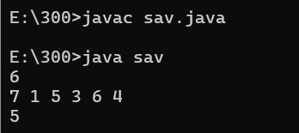

PROGRAM 1

import java.util.Scanner;

import java.io.*;

class original{

void count(){

Scanner scan=new Scanner(System.in);

int n=scan.nextInt();

int a[]=new int[n];

for(int i=0;i<n;i++){

a[i]=scan.nextInt();

}

int og=scan.nextInt();

for(int i=0;i<n;i++){

if(og==a[i]){

int ans=og*2;

og=ans;

}

}

System.out.println(og);

}

}

public class zero extends original{

public static void main(String[] args){

original o=new original();

o.count();

}

}

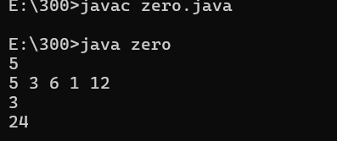

PROGRAM 3

import java.util.Scanner;

import java.io.*;

class array{

void zero(){

Scanner scan=new Scanner(System.in);

int n=scan.nextInt();

int a[]=new int[n];

for(int i=0;i<n;i++){

a[i]=scan.nextInt();

}

for(int i=0;i<n;i++){

for(int j=i+1;j<n;j++){

if(a[i]>a[j]){

int temp=a[i];

a[i]=a[j];

a[j]=temp;

}

}

}

for(int i=0;i<a.length;i++){

System.out.print(a[i]+" ");

}

}

}

public class io extends array{

public static void main(String[] args){

array ar=new array();

ar.zero();

}

}

